Project Design Phase-II
Data Flow Diagram & User Stories

Date: | 10 Feb 2026
Team ID: | LTVIP2026TMIDS35994
Project Name: | Househunt: finding your perfect rental home
Maximum Marks: | 4 Marks

📊 Level 0 DFD (Context Level Diagram)
This diagram shows the interaction between the Rent Ease system and external entities.
External Entities:
- User (Renter / Owner / Admin)
- Property Database
- Payment System (optional / future)
Main Process:
- Rent Ease – House Rental Management System
Data Flows:
- User Registration / Login → System
- Property Search & Booking Request → System
- Booking Confirmation / Status → User
- Property Details ↔ Database
- User & Booking Data ↔ Database
- 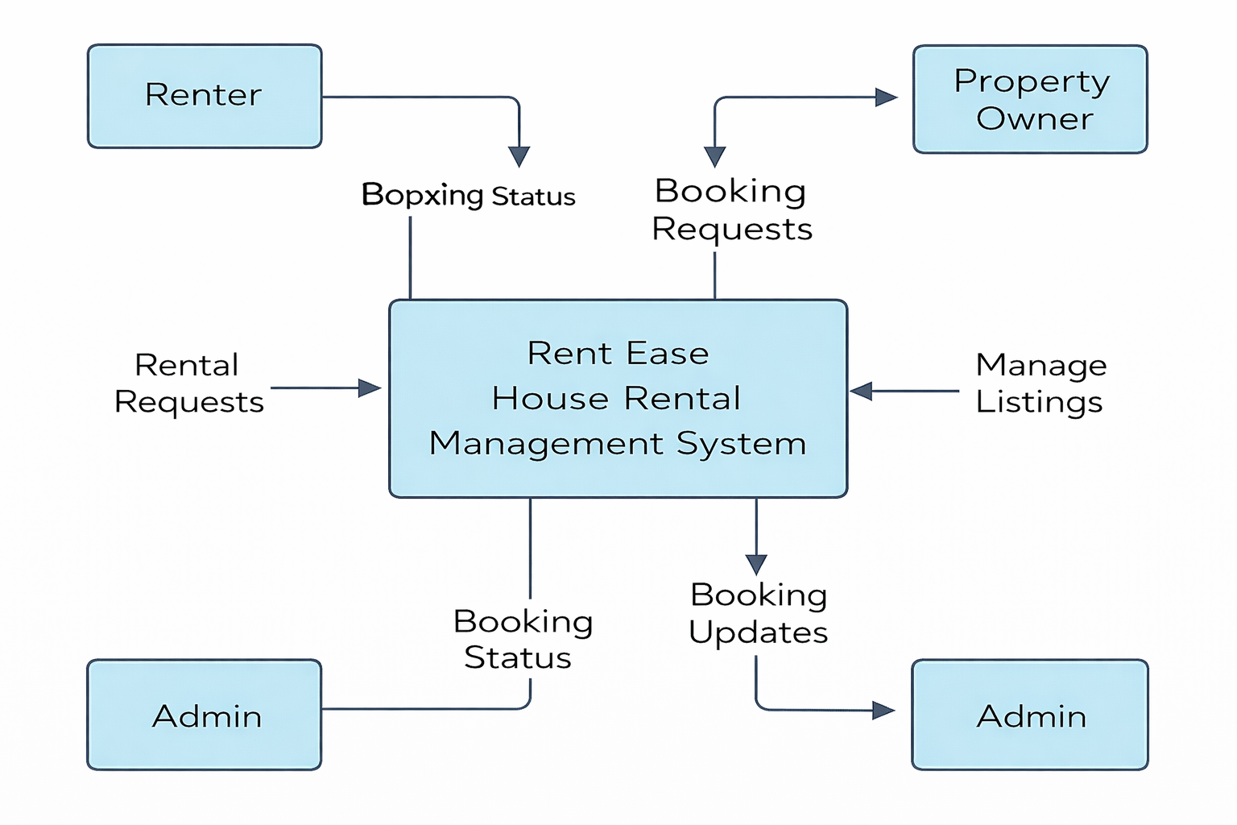
📊 Level 1 DFD (Detailed Diagram)
Process Breakdown
- User Management
  - User registers or logs in (Renter / Owner / Admin)
  - Authentication details are verified
- Property Management
  - Owner adds, updates, or deletes property listings
  - Properties are stored in the database
- Search & Browse
  - Renters browse available properties
  - Filter by location, price, and availability
- Booking Management
  - Renter sends booking request
  - Owner approves or rejects booking
  - Booking status updated in database
- Admin Management
  - Admin manages users, properties, and bookings
  - Admin monitors system activity
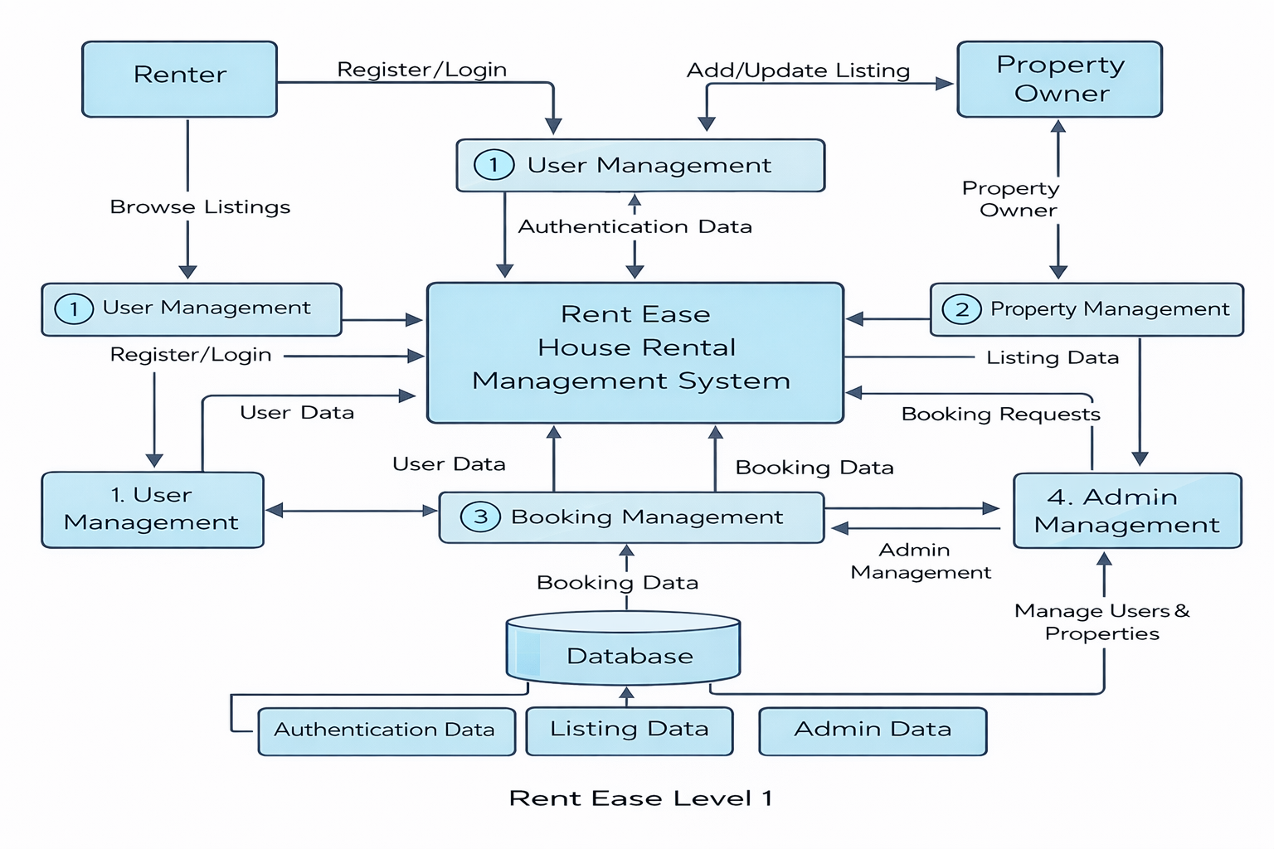
🧾 User Stories:
User Type | Functional Requirement (Epic) | User Story No | User Story / Task | Acceptance Criteria | Priority / Release
Renter | Property Search | USN-1 | As a renter, I want to browse available rental properties. | I can view a list of properties with location, price, and availability. | High / Sprint-1
Renter | Booking Property | USN-2 | As a renter, I want to send a booking request for a property. | Booking request is submitted and status is displayed. | High / Sprint-1
Renter | User Account | USN-3 | As a renter, I want to register and log in to the system. | I can successfully log in and access my dashboard. | Medium / Sprint-1
Owner | Property Management | USN-4 | As an owner, I want to add and manage my rental properties. | Property details are saved and visible to renters. | High / Sprint-2
Owner | Booking Approval | USN-5 | As an owner, I want to approve or reject booking requests. | Booking status updates correctly after action. | High / Sprint-2
Admin | User Management | USN-6 | As an admin, I want to manage users in the system. | Admin can view and control user accounts. | Medium / Sprint-3
Admin | System Monitoring | USN-7 | As an admin, I want to monitor properties and bookings. | Admin dashboard displays all system activities. | Low / Sprint-3

